**Assignment - Git and Github**

**Git repository link:** [**https://github.com/Data-Gyan/SampleOS**](https://github.com/Data-Gyan/SampleOS)

**Task 1 : 15 Commands**

1. initializing empty directory with git.

git init

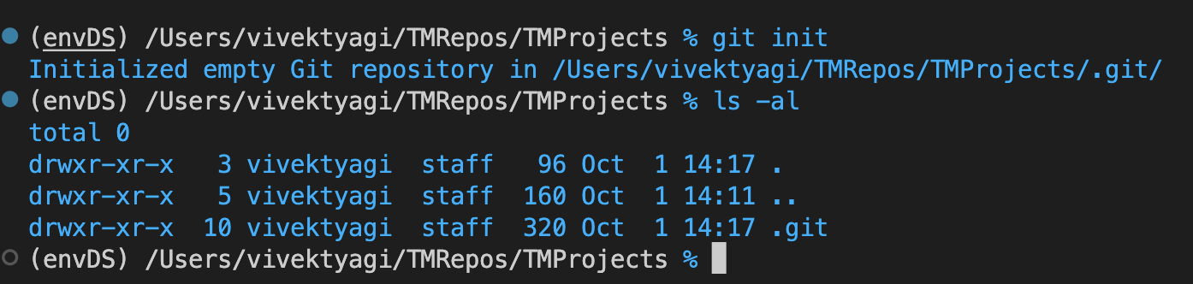

1. Setting fetch and push repository mapping on local.

git remote add origin “<https://github.com/Data-Gyan/TMProjects.git>”

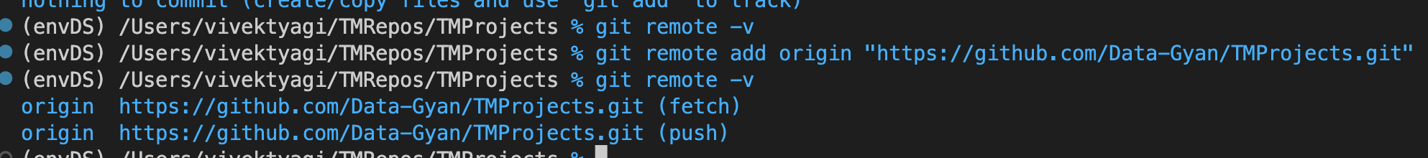

1. Check for remote repository mapping.

git remote -v

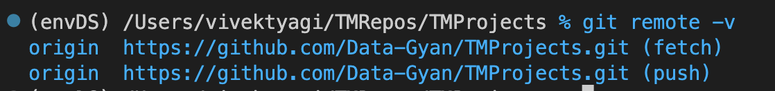

1. Getting git status (Ready to commit, Untracked, Branch) for files and folders

git status

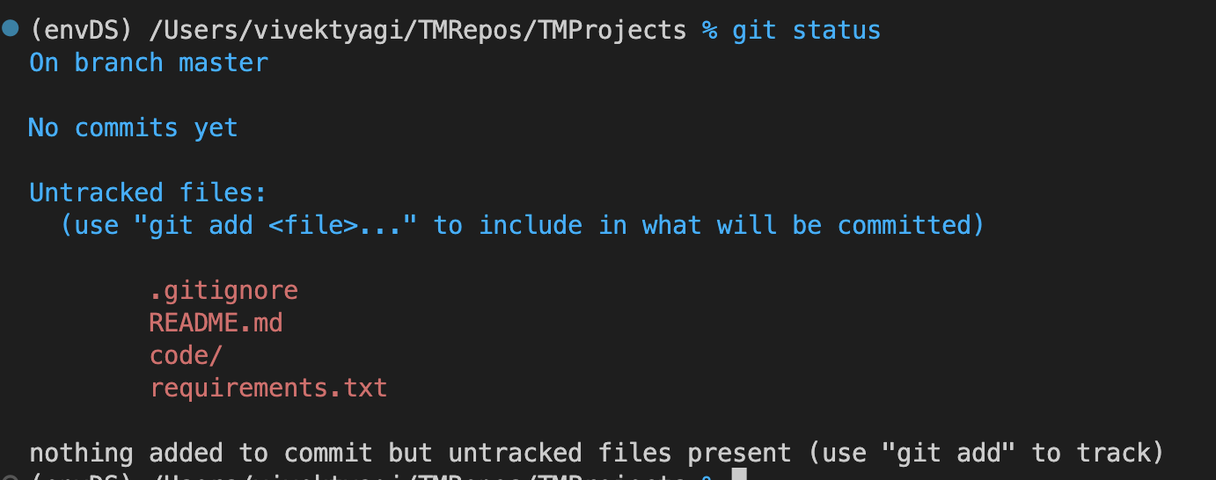

1. Add all the files in current folder to the main branch on local

git add .

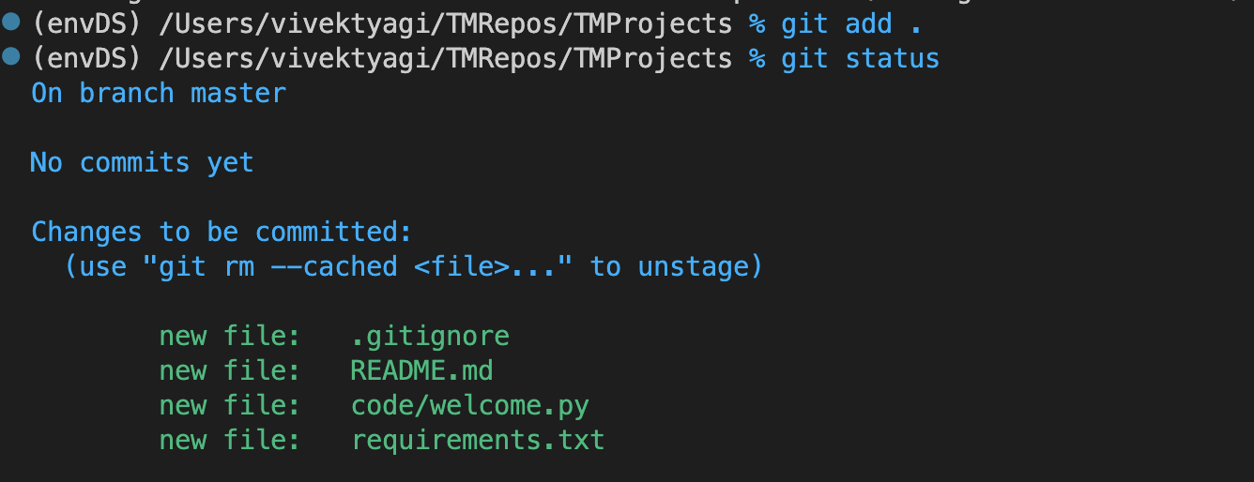

1. Commit the changes already staged into local repository

git commit -m “first commit in setting the project directory structure”

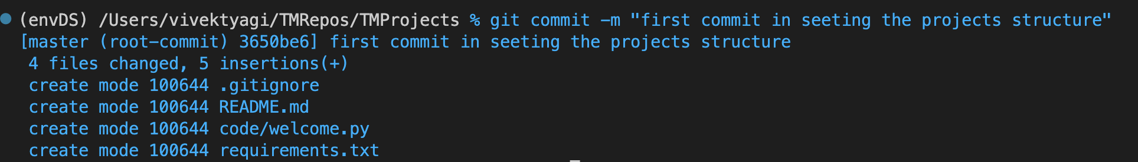

1. Fixing upstream branch mapping with origin

git push –set-upstream origin master

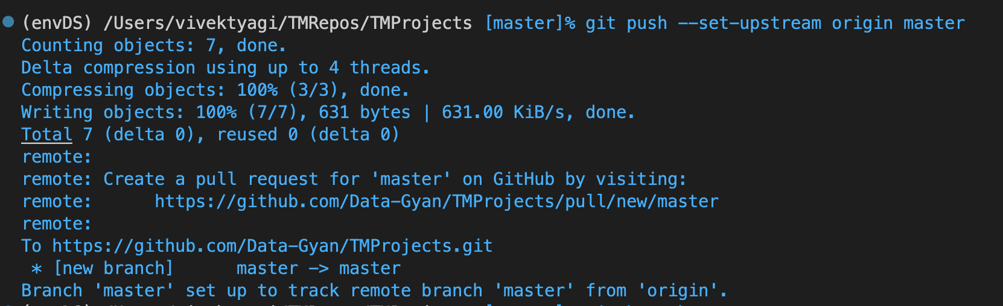

1. Check for upstream branch

git branch -a

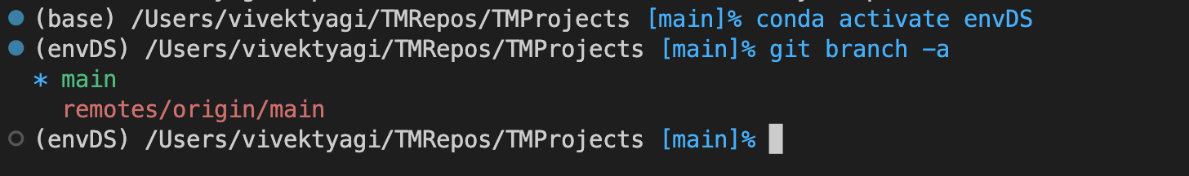

1. Removes the file from git tracking

$ git rm –cached requirement.txt

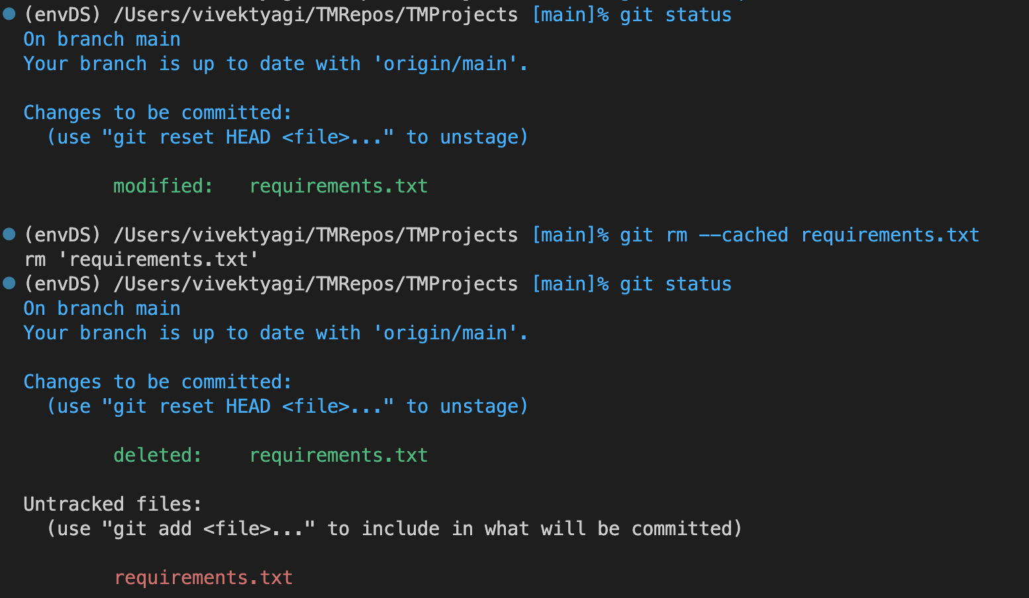

1. Pull down latest from a remote repository to your local git vault (repository). Here the repository is already set to remote one.

< git pull>

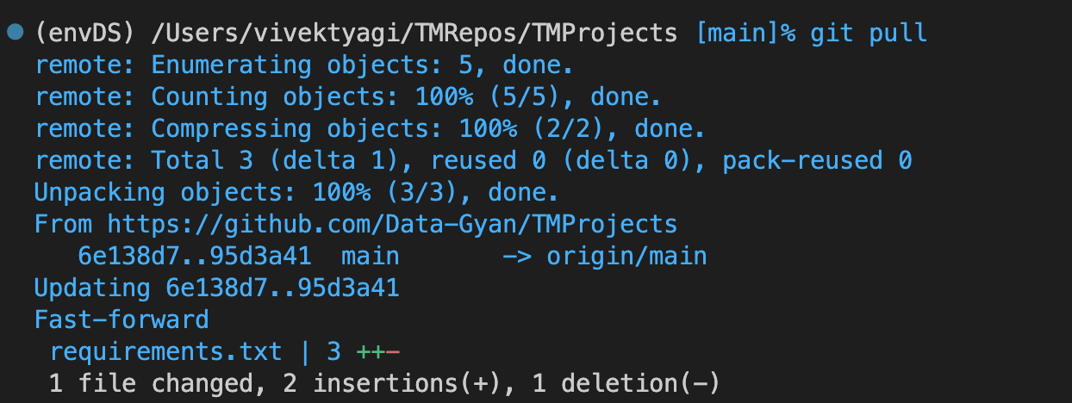

1. Creates a new branch with name 'myTempBranch'

<git branch myTempBranch>

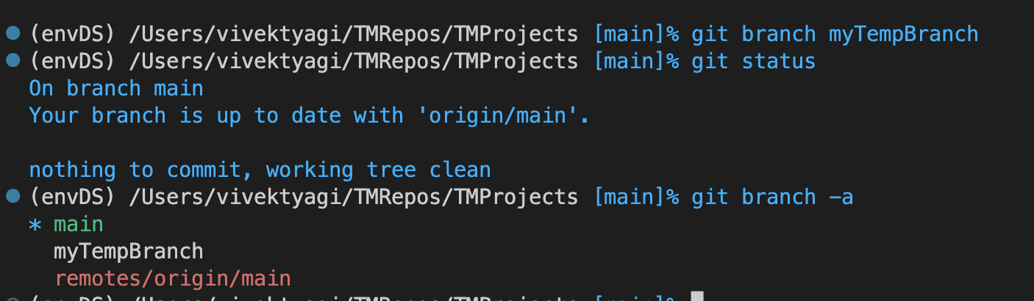

1. Move to the new branch named myTempBranch

< git checkout myTempBranch>

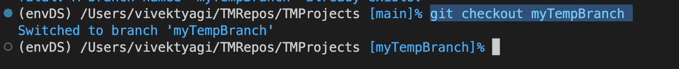

1. Clone a remote branch into local repository

< git clone https://github.com/flocsy/BodyBatteryDF.git >

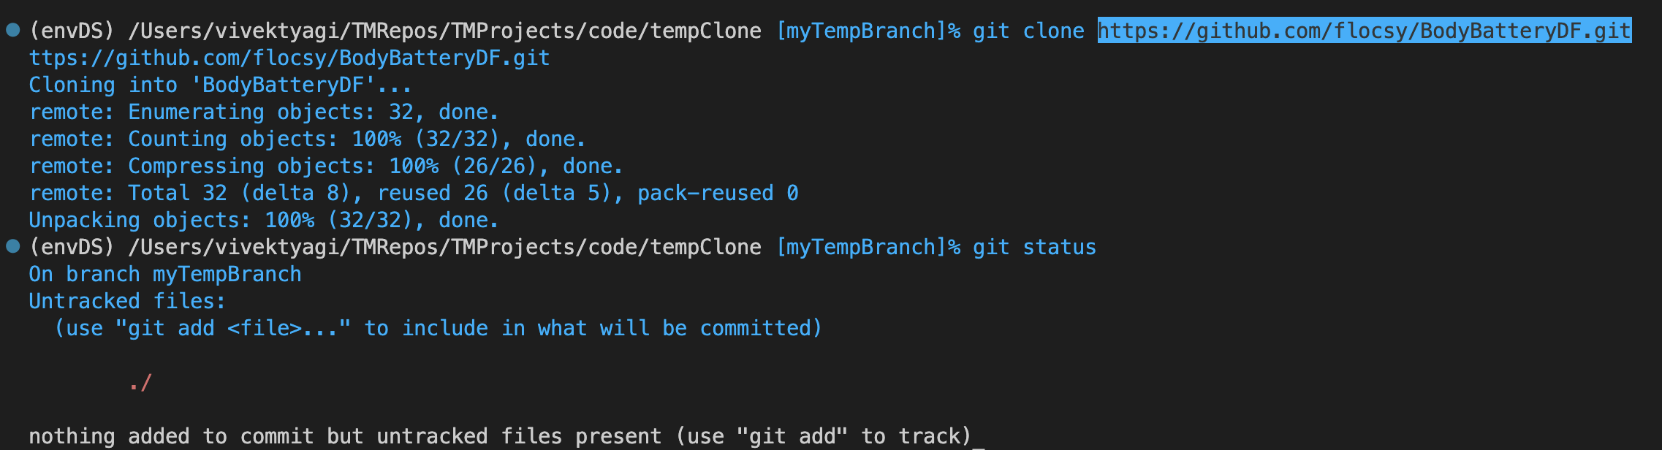

1. Delete remote branch on the server

< git push devBr --delete devBr>

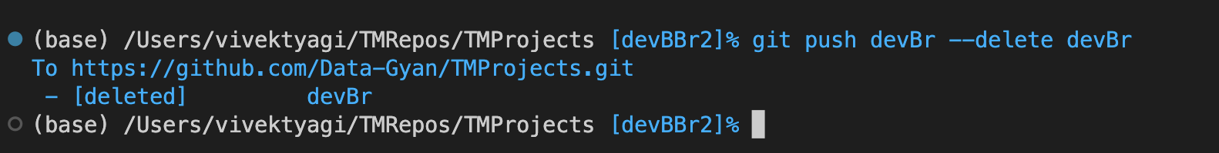

1. Create a git stash for file sharing or review

<git stash save “firstStash”>

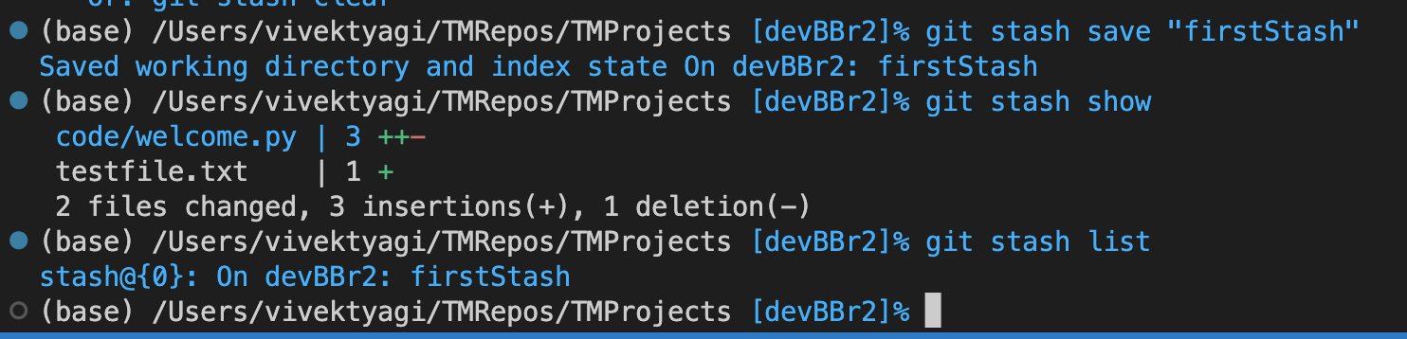

1. Undo the last staged changes

<git reset>

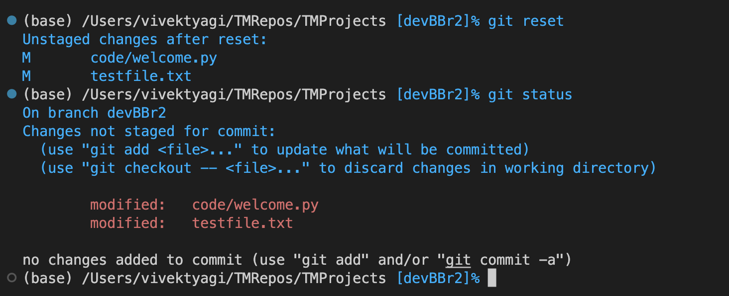

1. Logs the last activities from the git

< git log>

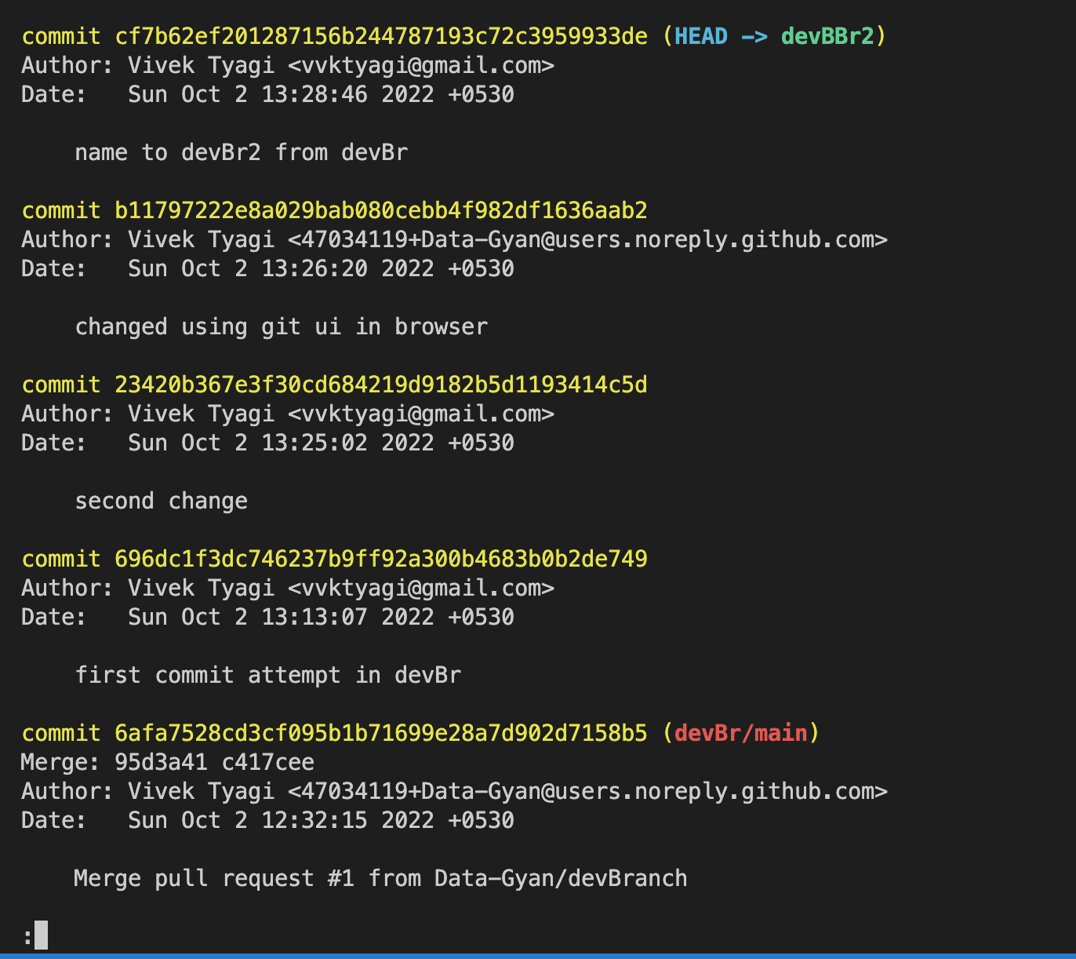

1. Rewriting branches, updating commits and clearing history. Apply any commits of current branch ahead of specified one

<git rebase devBBr2>

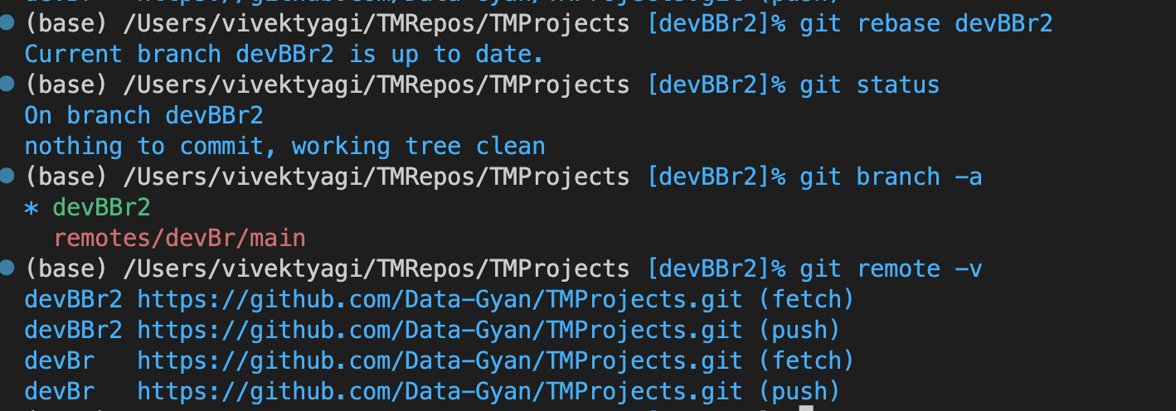

**Task 2:**

Consider that you want to start an open-source project in your organization. Perform all the standard operation to create a repository with minimal permission for all the users. It should contain.

* Proper open source structure

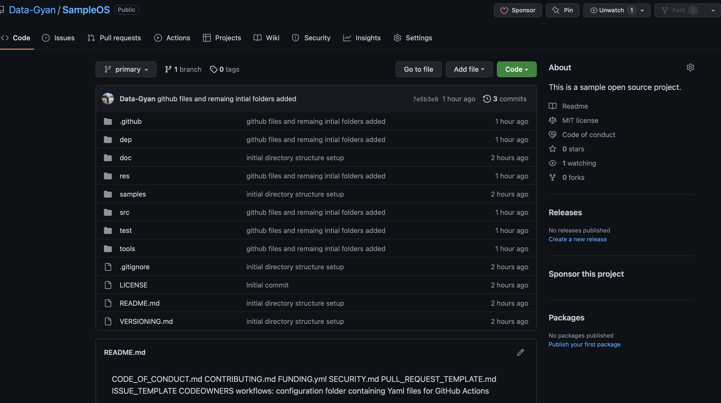

* Proper Readme

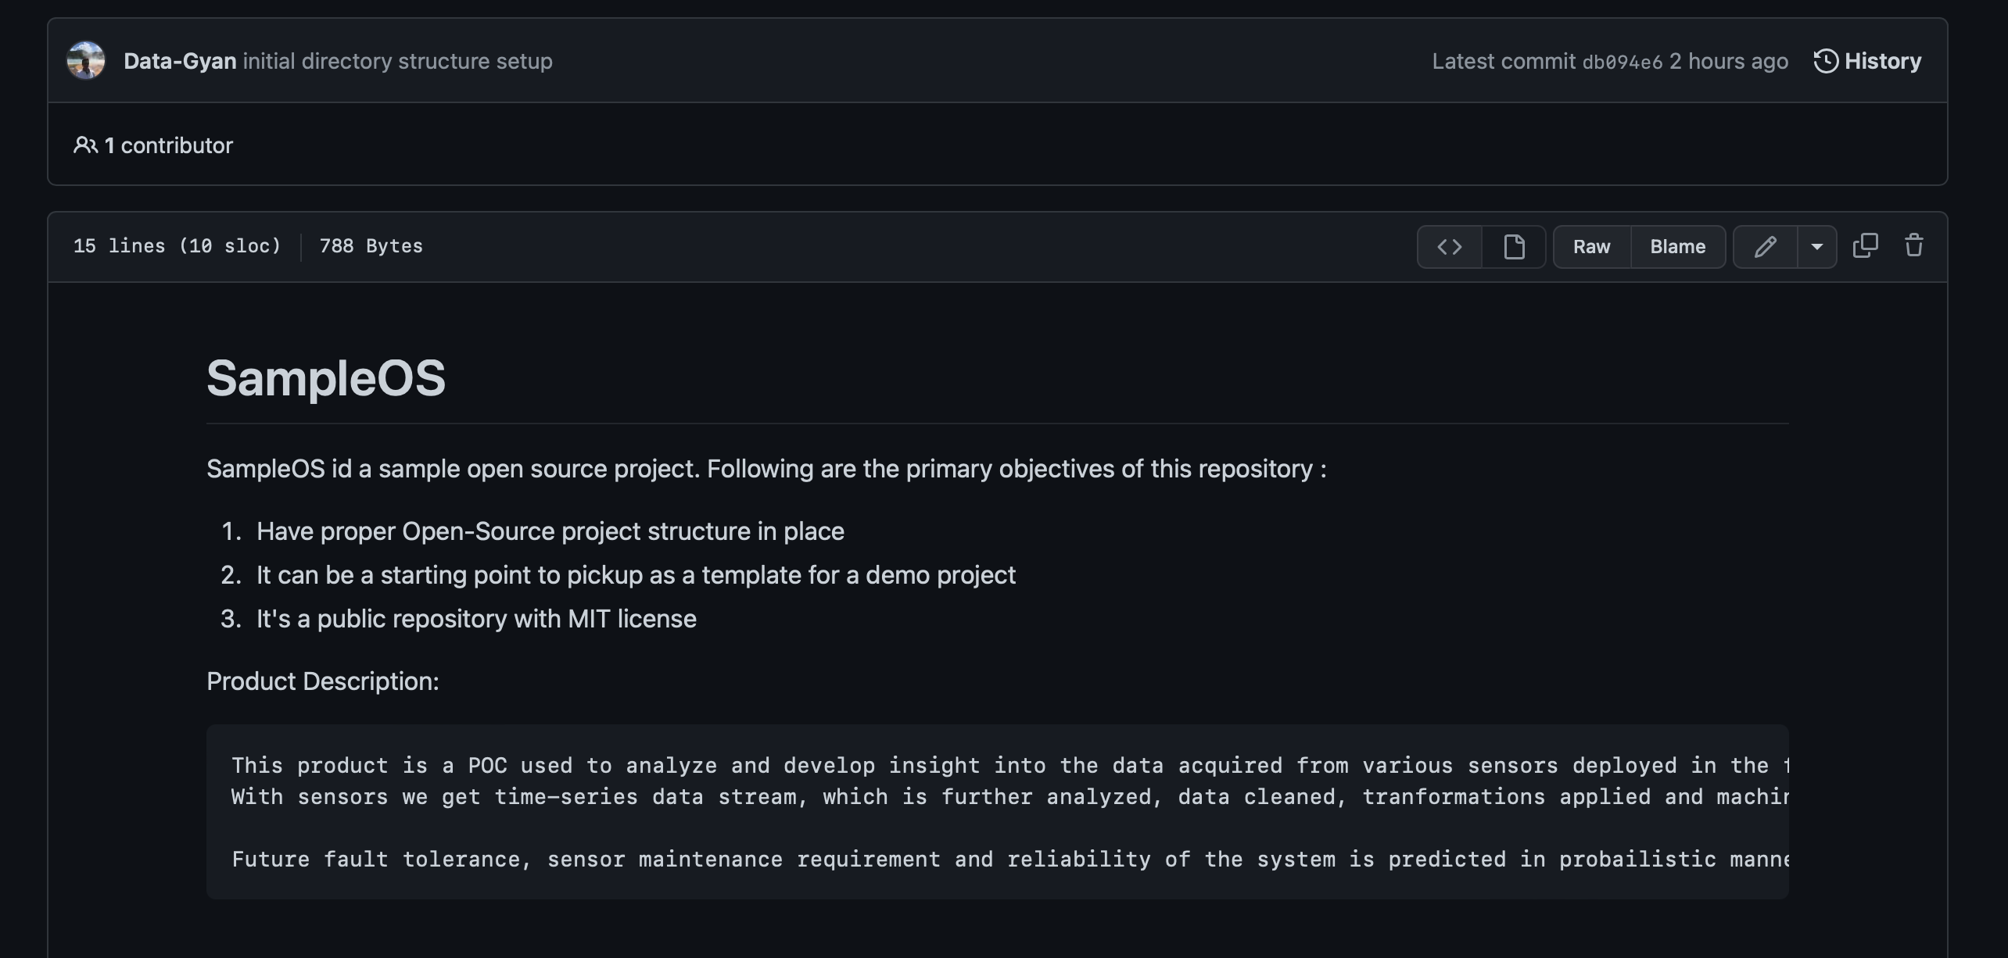

* Add 2 collaborator

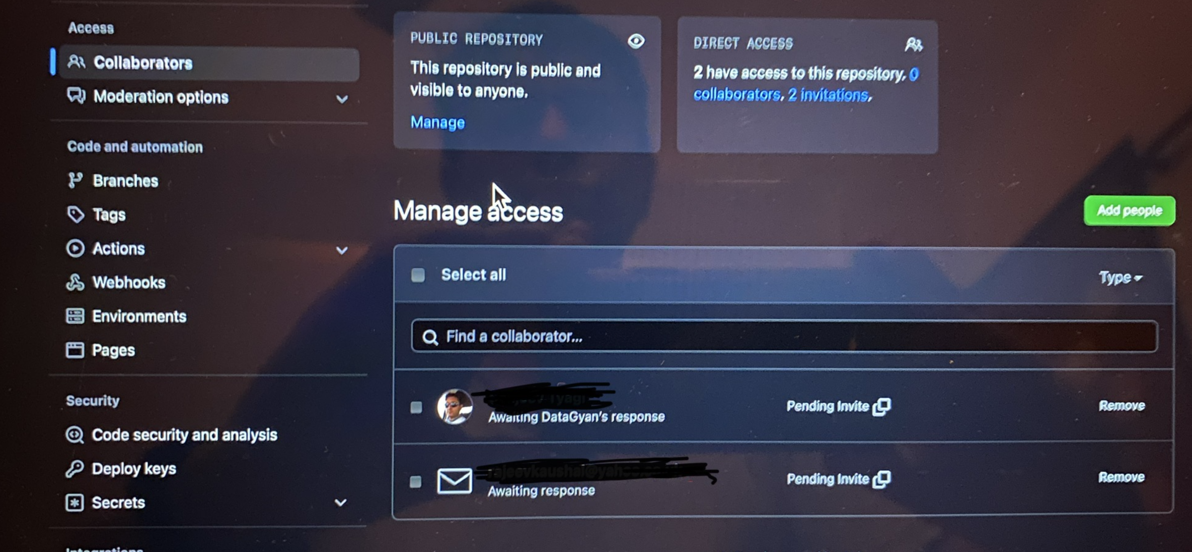

* Host GitHub Pages using settings (Designed to host your personal, organization, or project pages from a GitHub repository)

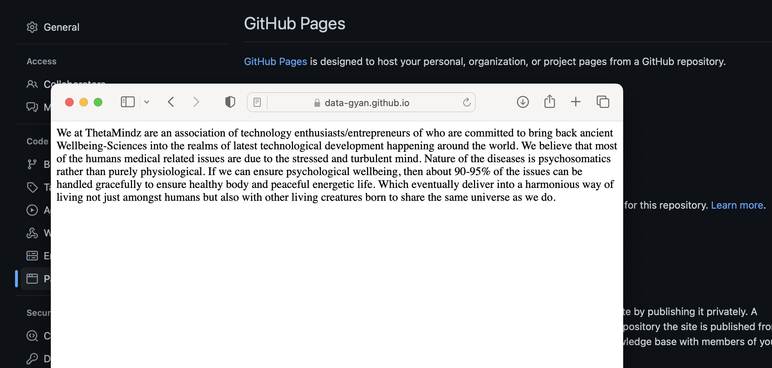

**Task 3:**

* Create a Issue in your github repository.

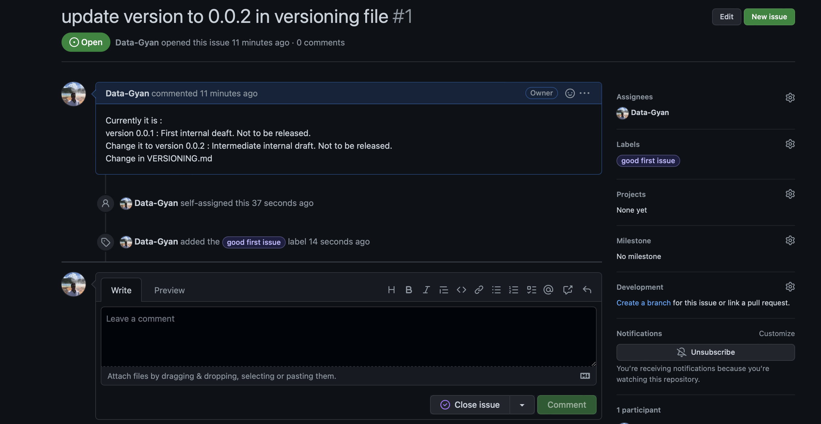

* Raise a pull request.

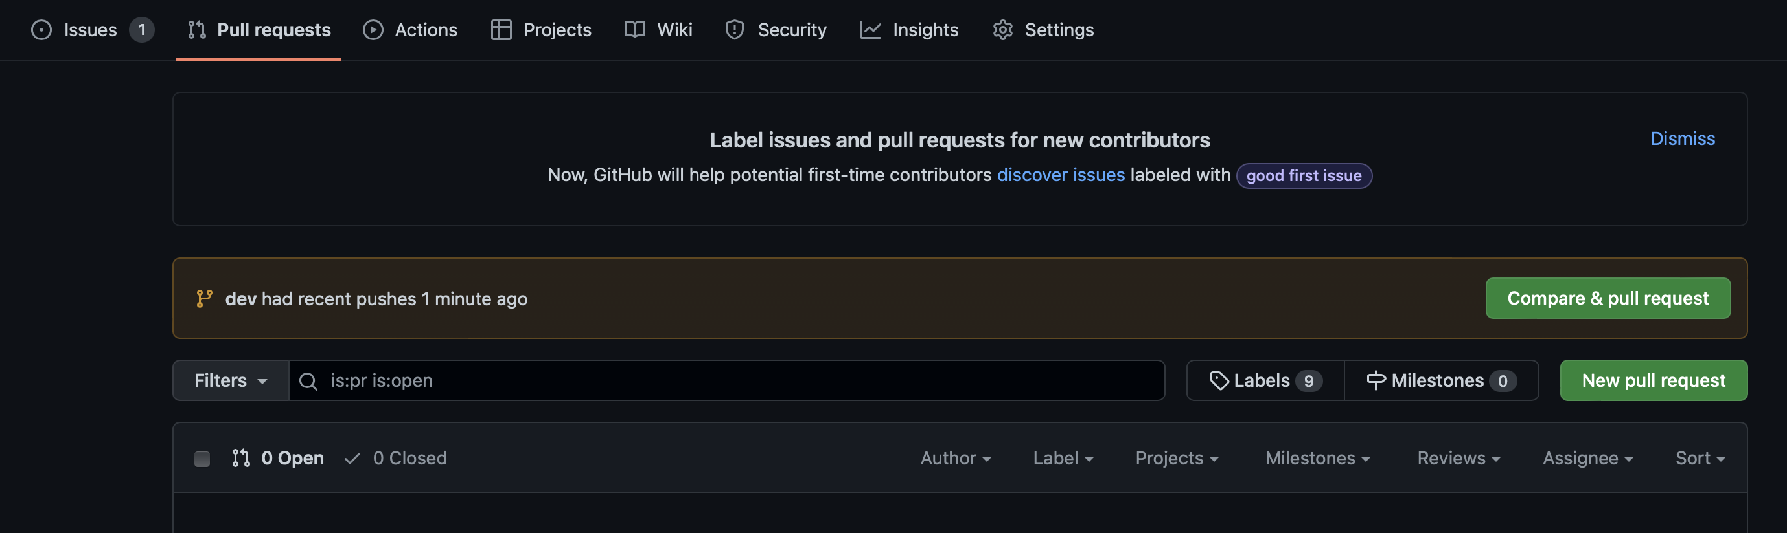

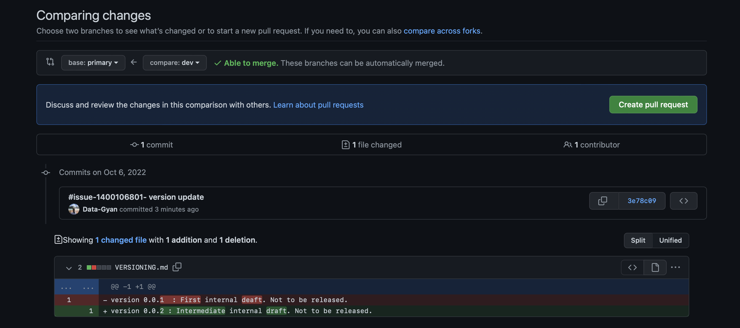

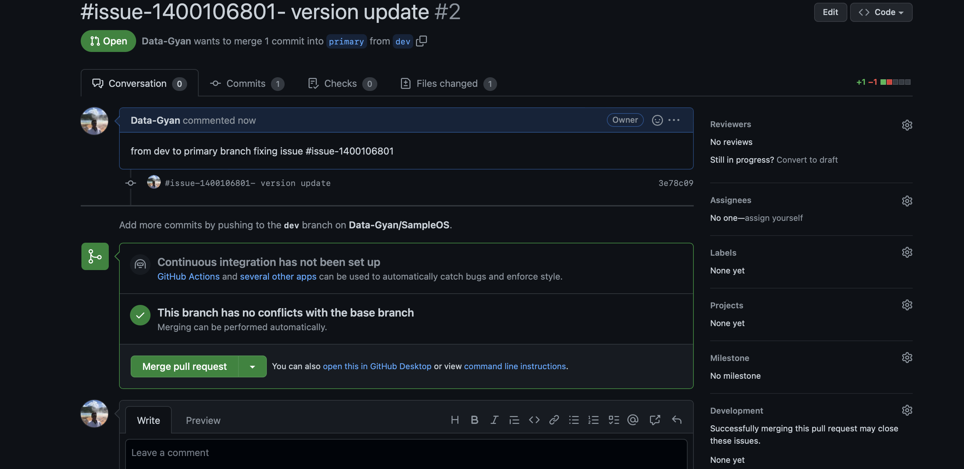

* Merge A pull request.

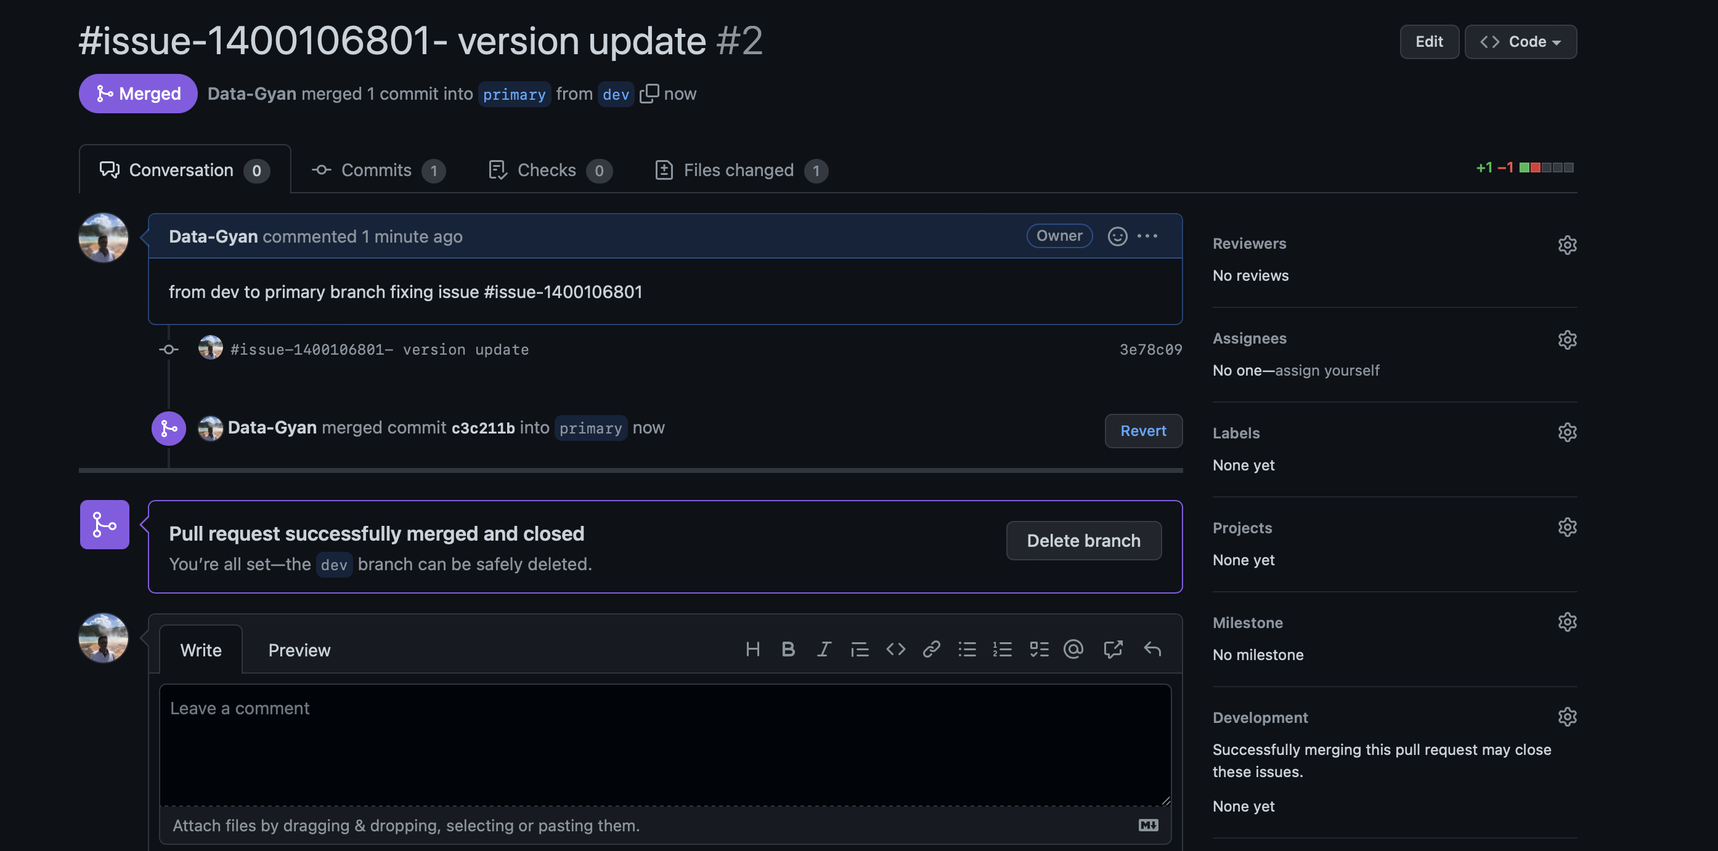

* Reject a pull request with proper comments.

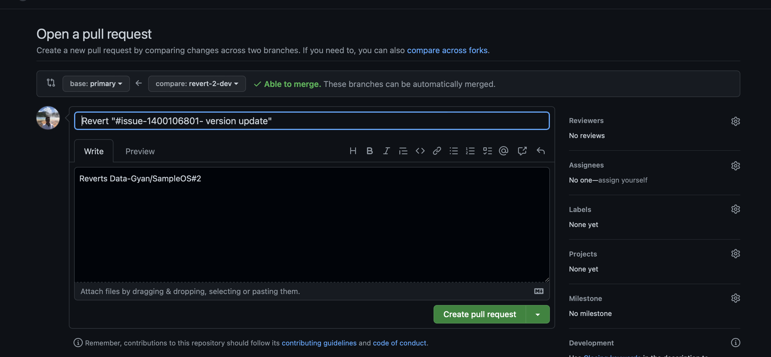

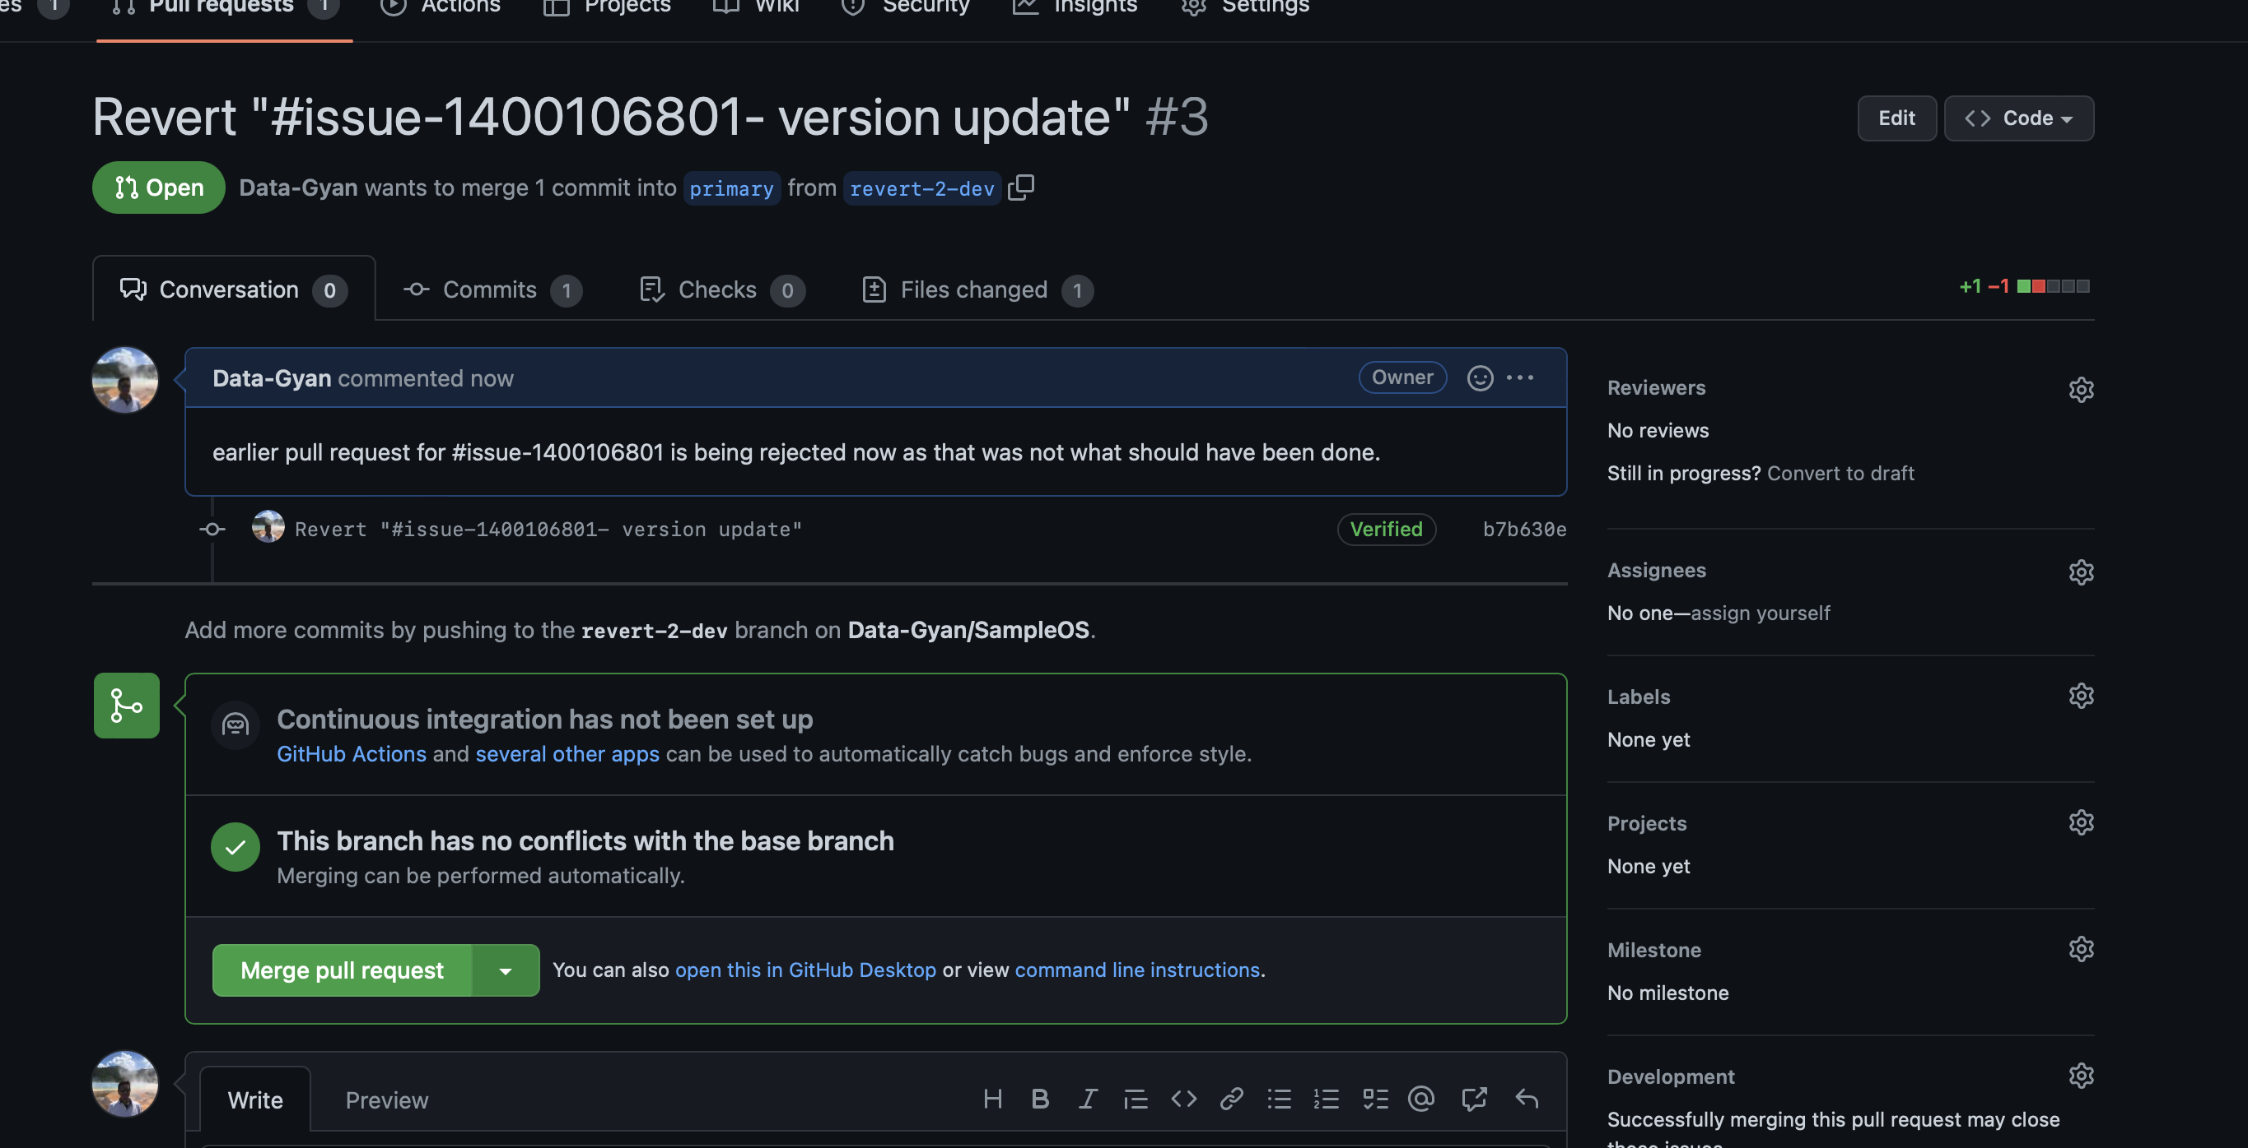

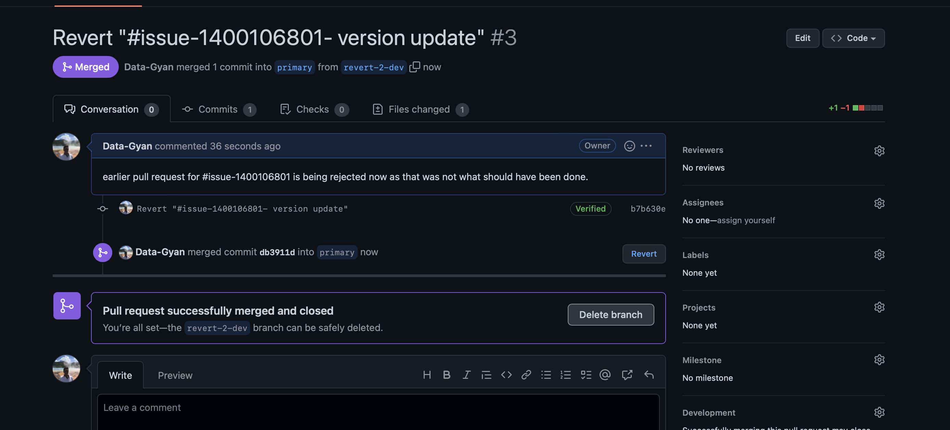

* Add a Dependabot alerts in your github.(for above cases)

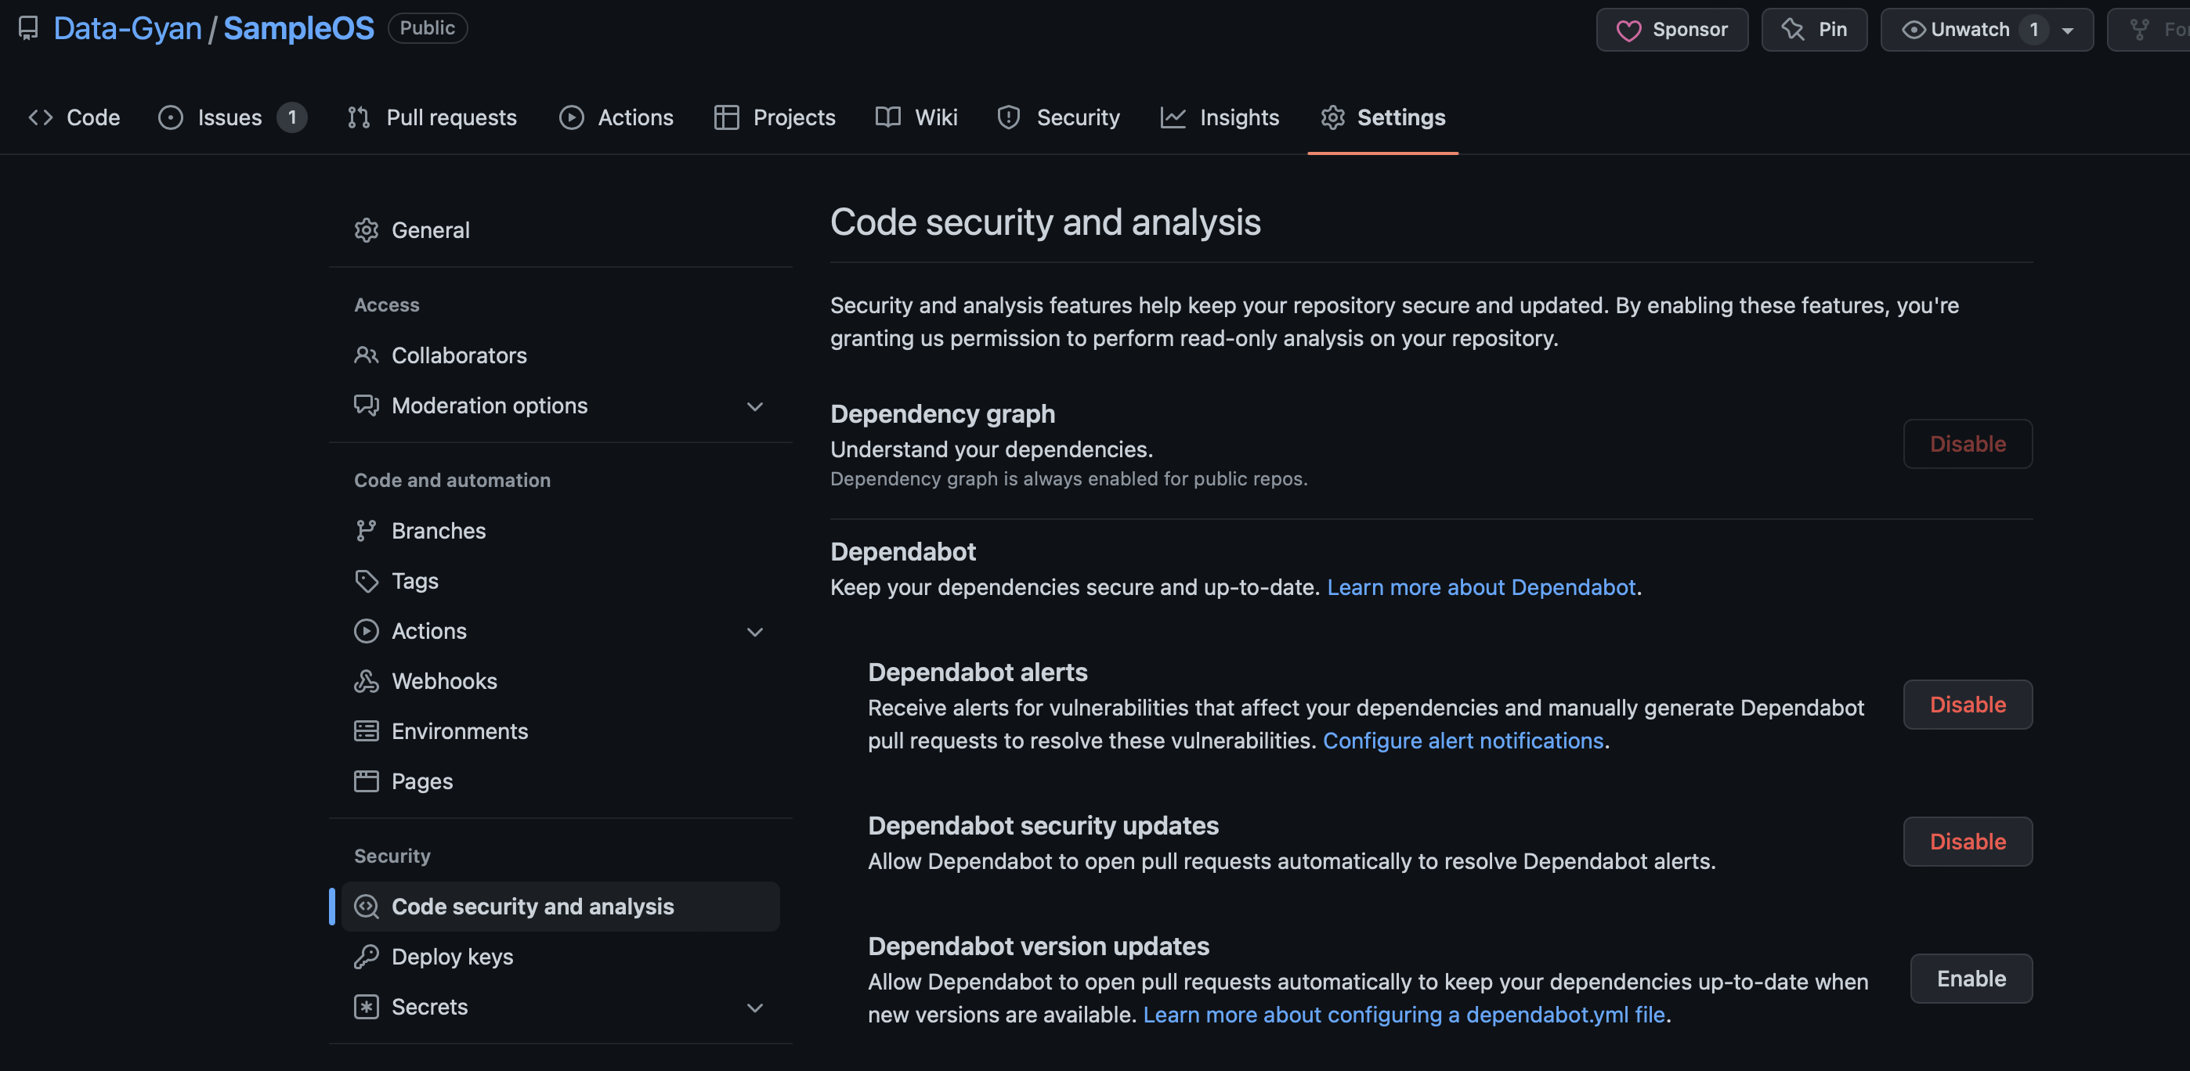

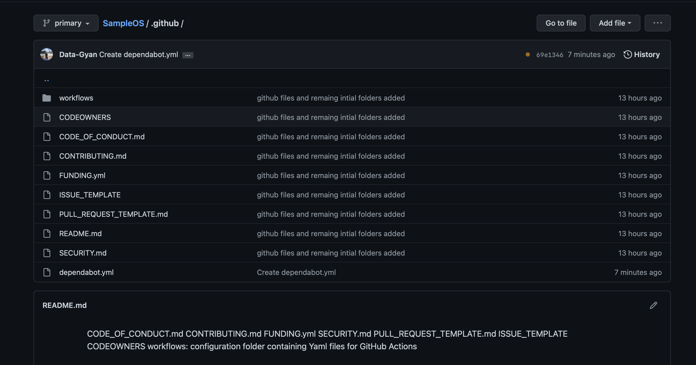

* Stash changes

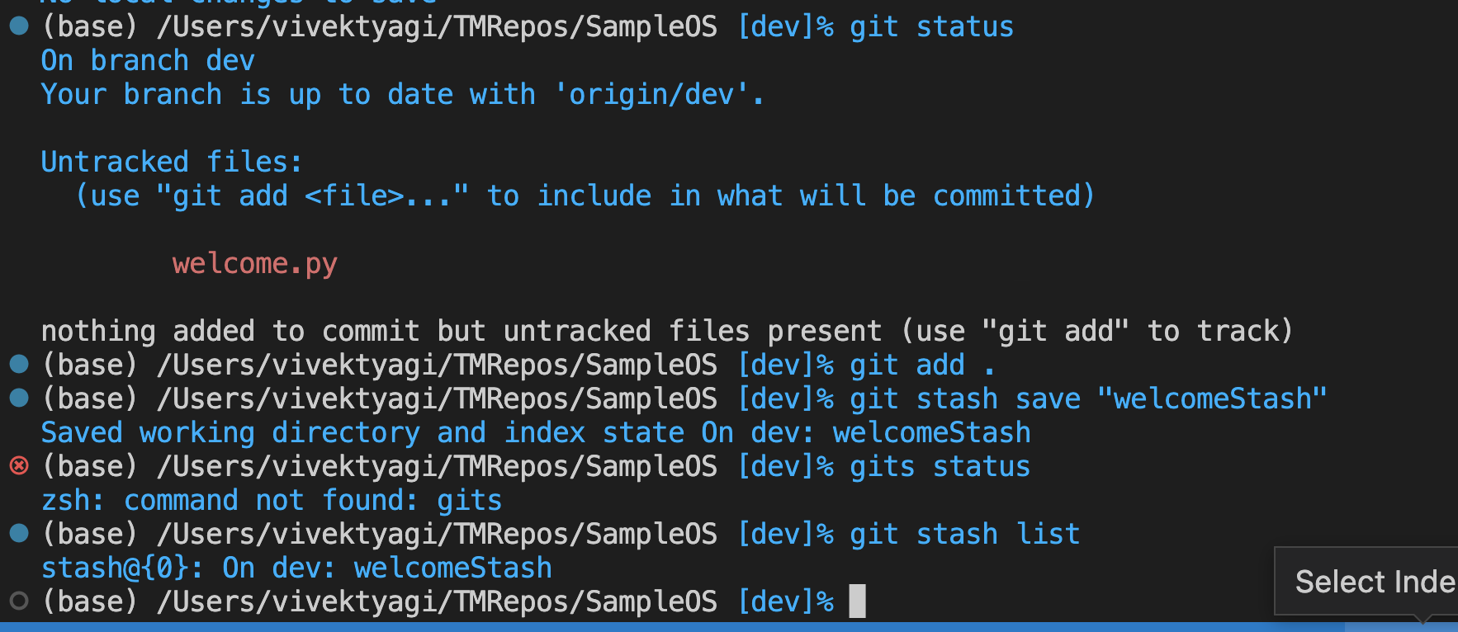

* Create a release your package

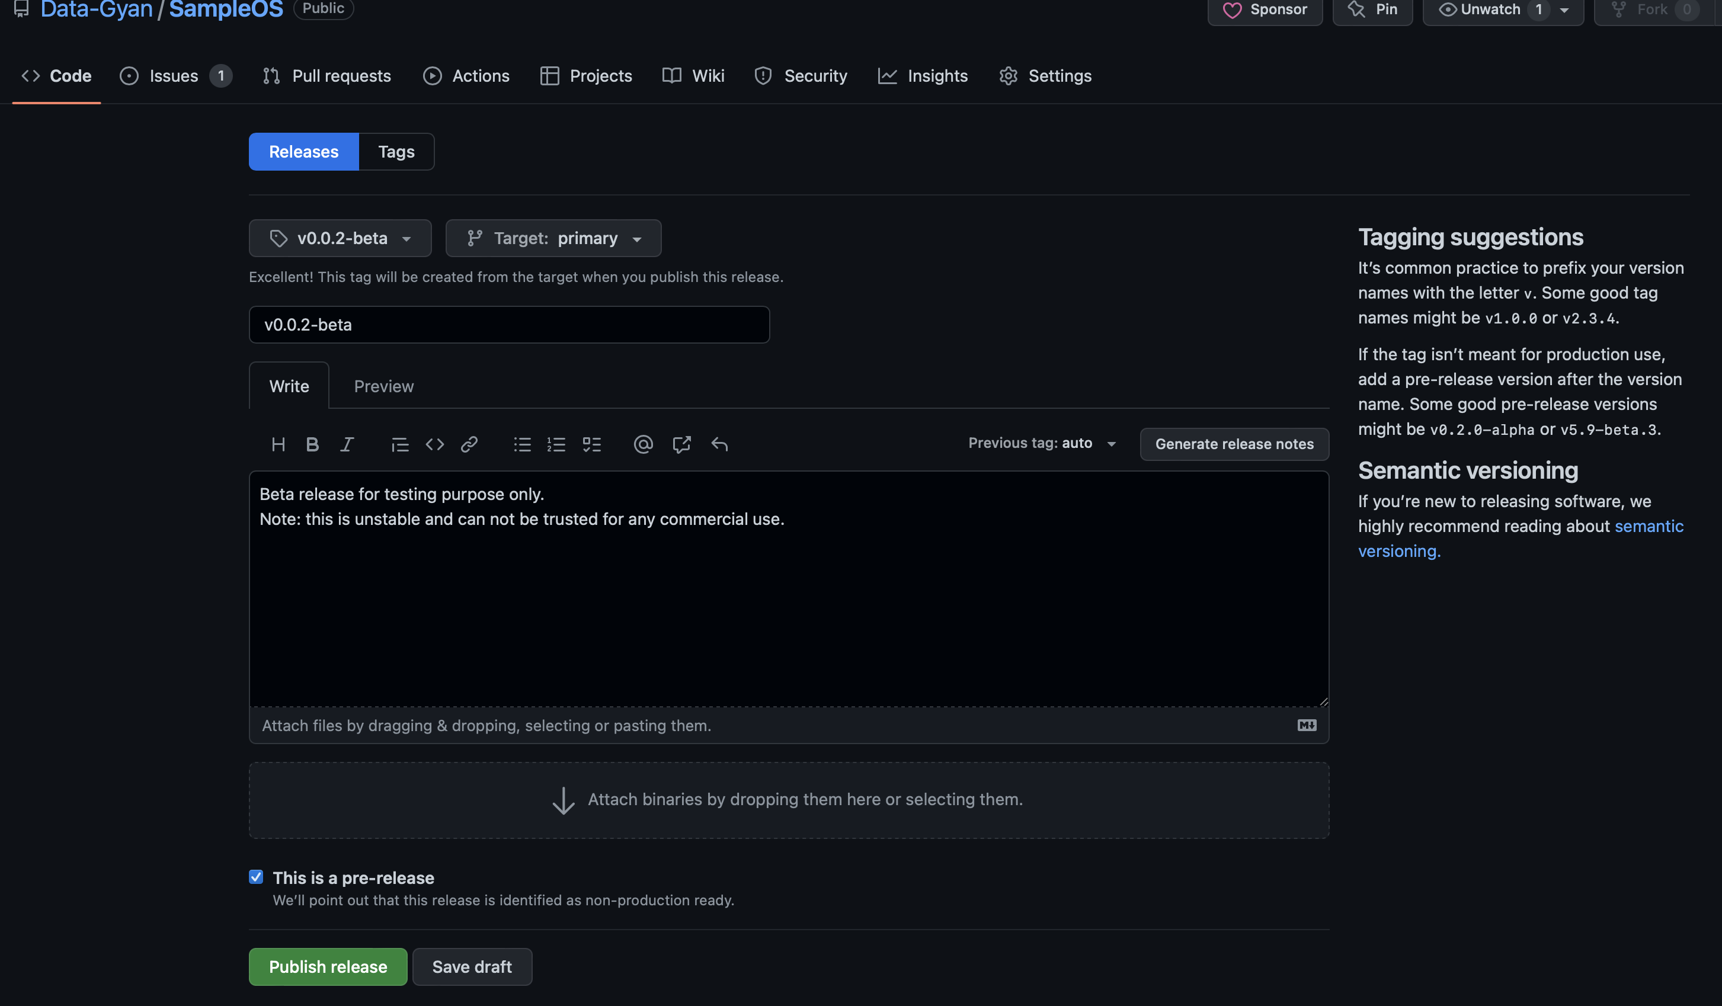

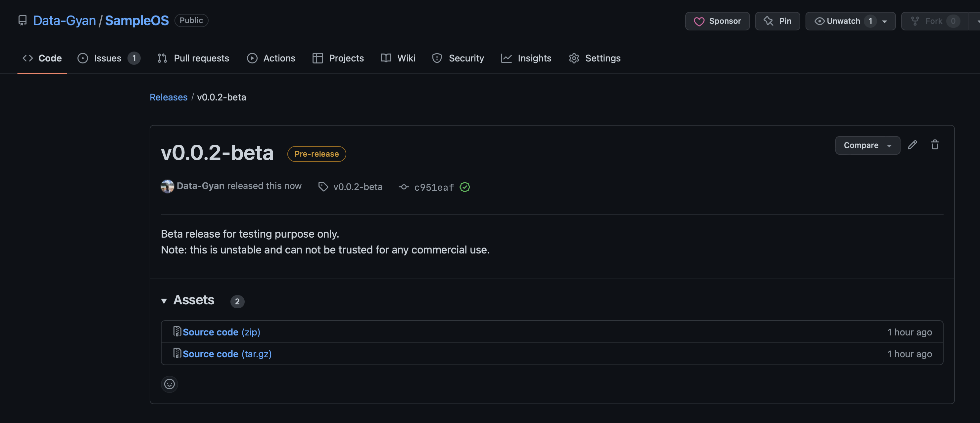

* Setup a Projects Board for your project.

